**Tools**

*These links are for your use only, as sources of images used below if they are not high quality enough in this doc.*

1. Adium tool guide [– Link](https://ssd.eff.org/en/module/how-use-otr-mac)
2. Basic Security Setup for Android - [Link](https://securityinabox.org/android_basic)
3. ChatSecure tool guide - [Link](https://ssd.eff.org/en/module/how-install-and-use-chatsecure)
4. Cobian Backup Guide - [Link](https://securityinabox.org/cobian_main)
5. How to change your Facebook privacy settings - [Link](https://www.eff.org/deeplinks/2013/01/how-protect-your-privacy-facebooks-graph-search)
6. How to opt-out of Facebook's data broker relationships – [Link](https://www.eff.org/deeplinks/2013/02/howto-opt-out-databrokers-showing-your-targeted-advertisements-facebook)
7. How to opt-out of Twitter's data broker relationships – [Link](https://www.eff.org/deeplinks/2013/07/how-opt-out-twitters-tailored-advertisements-and-more)
8. Jitsi Tool guide – [Link](https://securityinabox.org/jitsi)
9. K9 & APG tool guide – [Link](https://securityinabox.org/k9_apg_main)
10. KeePassX tool guide – [Link](https://www.keepassx.org/screenshots/)
11. ObscuraCam Tool guide – [Link](https://securityinabox.org/obscuracam_main)
12. Orbot & Orweb tool guide – [Link](https://securityinabox.org/Orbot_main), [Link](https://securityinabox.org/orweb_main)
13. PGP for Linux tool guide – [Link](https://ssd.eff.org/en/module/how-use-pgp-linux)
14. PGP for Mac O SX tool guide – [Link](https://ssd.eff.org/en/module/how-use-pgp-mac-os-x)
15. PGP for Windows tool guide – [Link](https://ssd.eff.org/en/module/how-use-pgp-windows-pc)
16. Pidgin tool guide – [Link](https://ssd.eff.org/en/module/how-use-otr-windows)
17. Psiphon3 tool guide – [Link](https://www.level-up.cc/leading-trainings/training-curriculum/deepening/psiphon3)
18. Recuva – File Recovery Guide – [Link](https://securityinabox.org/recuva_main)
19. Redphone Tool guide – [Link](https://ssd.eff.org/en/module/how-use-redphone-android)
20. Signal Tool guide – [Link](https://ssd.eff.org/en/module/how-use-signal-%E2%80%93-private-messenger)
21. TextSecure tool guide – [Link](https://ssd.eff.org/en/module/how-use-textsecure-android)
22. Tor for Mac tool guide – [Link](https://www.torproject.org/projects/torbrowser.html.en#macosx)
23. Tor for Windows tool guide – [Link](https://ssd.eff.org/en/module/how-use-tor-windows#overlay=en/node/57/)
24. TrueCrypt Tool Guide – [Link](https://securityinabox.org/truecrypt_main)

**OBSCURACAM TOOL GUIDE**

# ****ObscuraCam**** Tool Guide

# Encrypted email for Android

**Lesson to read:**

* **Mobile Phones**
* **Social Media**

**Download Location:** [**ObscuraCam homepage**](https://guardianproject.info/apps/obscuracam/)

**Phone requirements:** Android 2.3.3 and up

**Version used in this guide:** 2.0-RC2b

**License:** Free and Open Source Software (GPL v3)

**Level:**Basic

**Time required:** 5 minutes

**Using ObscuraCam** **will give you**:

* The ability to obscure identities by **hiding faces in photos taken with your Android device**
* An easy way to **share or save these "obscured" photos**

## 1.1 Things you should know about this tool before you start

* **ObscuraCam**'s automatic face-recognition does not *always* work, but you can easily select and obscure faces manually.
* On some versions of the Android operating system, the option to delete the original media file does not work. If you rely on this option, please check to make sure that you do not have **ObscuraCam**photos (with visible faces!) somewhere on your device.
* If you use **ObscuraCam**to send photos to yourself or to someone else, the tool **does not** provide additional protection (such as end-to-end encryption) for the photo in transit.
* A **tag**is an area in the photo which has been obscured by one of several methods **ObscuraCam**can use.

**2. How to Install and Use ObscuraCam**

2.0 How to Install ObscuraCam

2.1 Using ObscuraCam to obscure photos

2.1.1 Taking and Obscuring New Photos

2.1.2 Obscuring Existing Photos

2.2 Modifying the "blur" mode

2.3 Using ObscuraCam with Videos

2.3.1 Automatic Obscuring of Videos

2.3.2 Manual Obscuring of Videos

2.3.3 Changing Output Video Quality

## 2.0 How to Install ObscuraCam

**Step 1.** On your Android device, **download** and **install** the app from the [Google Play store here](https://play.google.com/store/apps/details?id=org.thoughtcrime.securesms) by tapping “Install”.

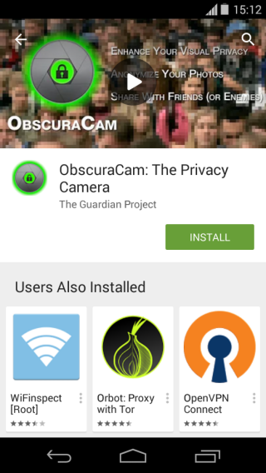

**Step 2:** Before the installation process begins, you will be prompted to review the access that the application will have on your phone. Review this carefully. Once you are happy with the permissions that will be granted, press “Accept” and the installation will complete. If you do not agree with the permissions that will be granted, press the back button and the installation will be cancelled.

**Step 3.** **Tap** Open to run the app for the first time

**Step 4:** Review the Terms of use and if you are happy with them press “Accept” to be brought to the main screen of **ObscuraCam**.

## 2.1 Using ObscuraCam to obscure photos

You can use **ObscuraCam**to hide some or all of the faces that appear in your photos. It works on pictures that you take with the **ObscuraCam**app itself, but you can also blur faces in other photos, as long as you have a way to copy or move the image files onto your Android device.

## 2.1 Taking And Obscuring New Photos

To take a photo on your Android device without showing your subjects' faces, perform the following steps:

**Step 1:** From the main screen of **ObscuraCam**tap “New Picture”.

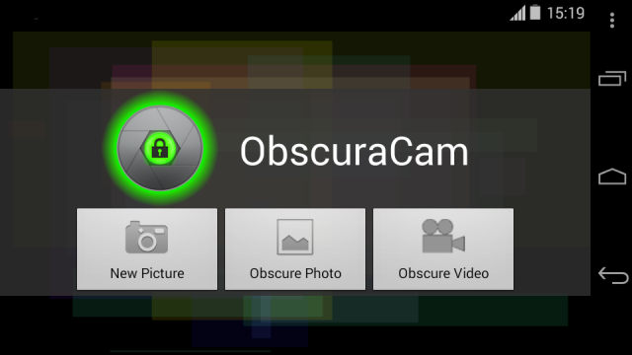

**Step 2:** Your phone's camera app will open, take a photo as you normally would.

**Step 3:** A screen with a preview of the photo you took will be displayed. **Tap**the tick to proceed with obscuring the photo, otherwise **tap**the x to discard the current photo and take another.

**Step 4:** ObscuraCam** will attempt to identify faces automatically.

**Step 5:** If **ObscuraCam**can detect faces in the photo it will add an image "tag" (a rectangle used to select content that should be hidden) over the face and pixelate it. If **ObscuraCam**did not detect any faces or you need to obscure additional areas on the photo, tap on the area to add additional tags.

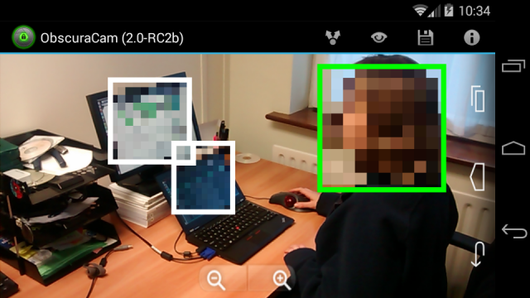

**Step 6:** To see a preview of the photo you can tap the eye icon, to return to the edit screen tap anywhere on the preview image.

**Step 7:** To share the obscured photo via an existing application on your phone such as K-9 Mail or TextSecure tap the icon made up of a dot with arrows.

**Step 8:** To save the blurred photo to your phone tap the save icon. You will be asked whether you want to delete the original, unblurred, image from your phone, if you no longer need the original photo tap “Yes” otherwise tap “No” to save a copy of both the obscured and unobscured photo.

## 2.1.2 Obscuring Existing Photos

As well as obscuring photos as you take them, **ObscuraCam**can also obscure any old photos on your phone or that you copy to your phone.

**Step 1:** From the main screen of **ObscuraCam**tap“Obscure Photo”.

**Step 2:** Browse to the file on your phone that you want to obscure.

**Step 3:** **ObscuraCam**will attempt to detect any faces in the image and pixelate them.

**Step 4:** If **ObscuraCam**did not detect any faces or you want to obscure additional faces or items in the photo tap the relevant area to add additional pixelation.

**Step 5:** To see a preview of the photo you can tap the eye icon, to return to the edit screen tap anywhere on the preview image.

**Step 6:** To share the obscured photo via an existing application on your phone such as K-9 Mail or TextSecure tap the icon made up of a dot with arrows.

**Step 7:** To save the blurred photo to your phone tap the save icon. You will be asked whether you want to delete the original, unblurred, image from your phone, if you no longer need the original photo tap “Yes” otherwise tap “No” to save a copy of both the obscured and unobscured photo.

## 2.3 Modifying the "blur" mode

## 2.3.1 Resize or move the tag

While editing a photo in **ObscuraCam**, if you need to resize the tag, touch one of the four corners of the white outline box so that it turns green and drag it to make it larger or smaller.

If you need to move the tag so that it is in a better position on the photo, touch the centre of the pixelated area so that the surrounding white box turns green, then drag the box to the location you want.

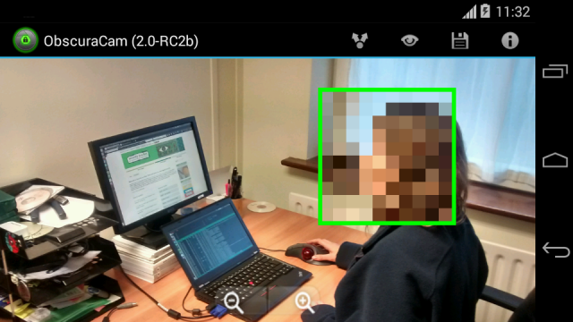

## 2.3.2 Change the obscure type

ObscuraCam gives you a few options on how to obscure a photo. From the edit screen tap on an existing obscured area to bring up the obscuring options:

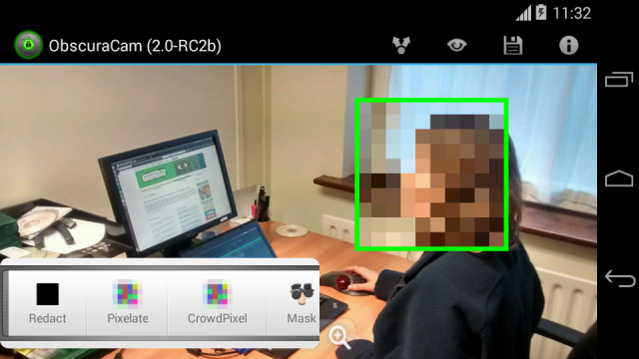

**Pixelate** will obscure any part of the photo inside the tag by pixelating it

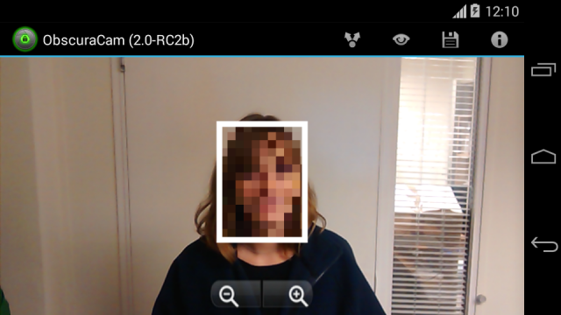

**Redact** will obscure any part of the photo inside the tag by placing a black box over it

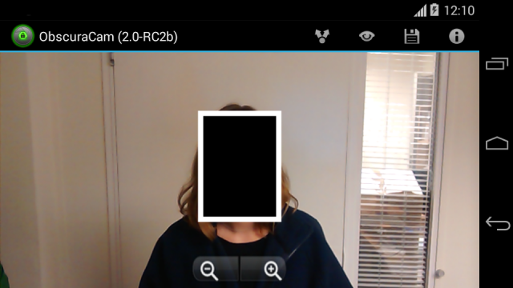

**Mask** will obscure any part of the photo inside the tag by placing a funny mask over the person

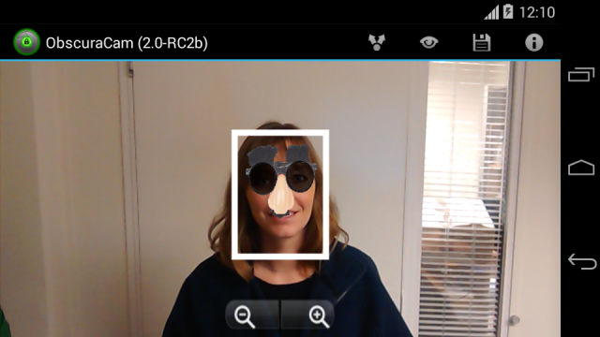

**Crowd Pixel** will obscure any part of the photo outside the tag by pixelating the rest of it.

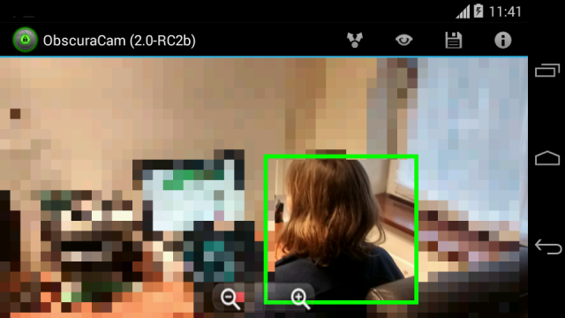

**Clear Tag** will remove the selected tag from the photo.

## 

## 2.3 Obscuring Videos

**Obscuracam**can also obscure faces or objects in videos, however unlike with photos it can only obscure existing photos that you took with your phone or copied to your phone

## 2.3.1 Automatic Obscuring of Videos

**Step 1:** From the main screen of **Obscuracam**tap “Obscure Video”.

**Step 2:** Select the video you with to obscure from your phones storage

**Step 3** Tap “Yes” when asked Would you like to detect faces in this video.

**Step 3:** The video will begin to play and **ObscuraCam**will attempt to detect faces. The process for detecting faces takes approximately 4 seconds for every 1 second of the video.

**Step 4:** Once the face detection has completed, you can tap Play to review the video. This will show you the pixelated tags over the faces as well as a green trail showing the path the tag takes through the video as the face moves.

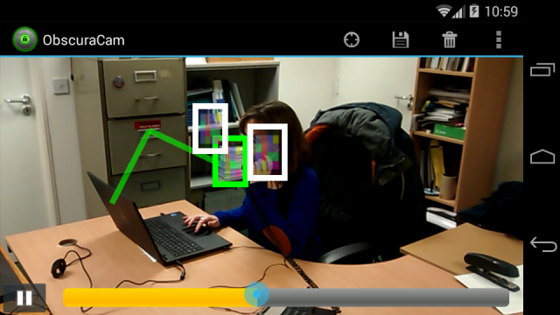

**Step 5:** After reviewing the video and you are happy that all faces are obscured, tap the save icon at the top of the screen to save the video to your phones storage.

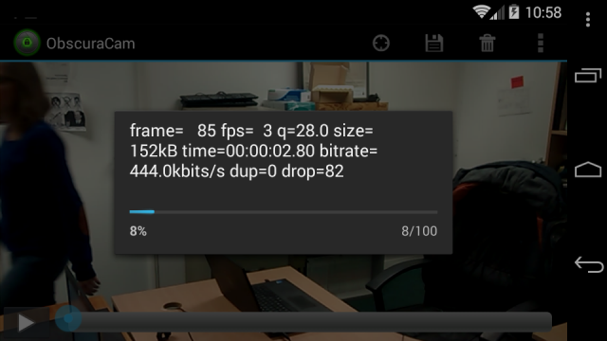

**Note:** If **ObscuraCam**did not properly obscure faces or failed to detect some, you can see how to manually obscure them in section below.

## 2.3.2 Manual Obscuring of Videos

If **ObscuraCam**was not able to detect faces properly during the automatic process or you would like more process over the obscuring process you can manually obscure video.

**Step 1:** From the main screen of **Obscuracam**tap “Obscure Video”.

**Step 2:** Select the video you with to obscure from your phones storage.

**Step 3:** Tap “No” when asked Would you like to detect faces in this video.

**Step 4:** Tap the play icon to start playing the video

**Step 5:** While the video plays, touch and hold your finger on a face in the video to add a tag over it, drag the tag around the screen with your finger following the movement of the face. Lift your finger off the screen to stop obscuring the video. **Note:** As you follow the face on the screen you will see a green trail being left behind, this is the path the pixelated tag will take once the video is saved.

**Step 6:** If there are additional faces in the video that you wish to obscure, touch and hold the blue circle and move the slider back to the time point where the next face appears on video and repeat step 5 above.

**Step 7:** Once you have finished manually obscuring faces, you can tap the play icon to review the video. This will show you the pixelated tags over the faces as well as a green trail showing the path the tag takes through the video as the face moves.

**Step 8:** After reviewing the video and you are happy that all faces are obscured, tap the save icon at the top of the screen to save the video to your phones storage.

## 2.3.3 Changing Output Video Quality

**ObscuraCam**chooses a default video quality when saving that make the video small enough to easily share via email or other methods but does reduce resolution and quality of the video.

To keep the obscured video in a higher resolution:

**Step 1:** After either automatically or manually detecting faces and before saving the video, tap the three vertical dots icon to bring up the menu and select “Preferences”.

**Step 2:** Review and change the settings you want, where possibly **ObscuraCam**will give you the range by which each setting can be changed.

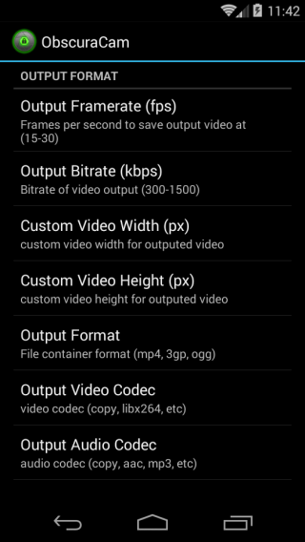

**Step 3:** Once you have made the desired output changes, tap the back button on your phone and save the video.

**ORBOT AND ORWEB TOOL GUIDE**

# Orbot & Orweb Tool Guide

# Circumvention and anonymity online for Android

**Lesson to read: The Internet**

**Download Location:**

* Orbot***:*** [***https://guardianproject.info/apps/***](https://guardianproject.info/apps/)orfrom [***Google Play***](https://play.google.com/store/apps/details?id=org.torproject.android)
* Orweb: [***https://guardianproject.info/apps/***](https://guardianproject.info/apps/) or from [***Google Play***](https://market.android.com/details?id=info.guardianproject.browser)

**Phone requirements**:

* Android 2.3 and up (Android 1.6 and up for Orweb)

**Version used in this guide:**

* Orbot: 14.0.4.3
* Orweb: 0.6.1

**License:**

* Orbot: Freeware – BSD
* Orweb: Free and Open Source Software (GPL v3)

**Level:**Advanced

**Time required:** 30-40 minutes

**Using Orbot & Orweb combined will give you**:

* The ability to conceal your digital identity from the websites that you visit.
* The ability to conceal the websites you visit from Internet Service Providers (ISPs) and other surveillance mechanisms.
* The ability to bypass Internet censorship and filtering rules.

**ORBOT**



**1.1 Things you should know about this tool before you start**

Orbot provides Android devices with access to the Tor Network. Form more information see the **Internet lesson**

2 How to Install and Configure Orbot

## 2.0 How to Install Orbot

## 2.1 How to Configure Orbot

## 2.0 How to Install Orbot

**Step 1:** On your Android device, **download**and **install**the app from the[**Google Play store here.**](https://play.google.com/store/apps/details?id=org.torproject.android)

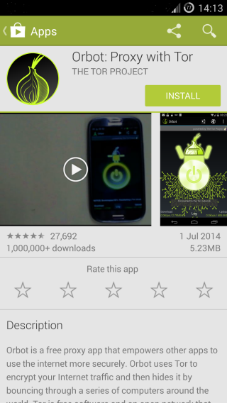

**Step 2:** Before the installation process begins, you will be prompted to review the access the application will have on your phone. Review this carefully. Once you are happy with the permissions that will be granted, press “Accept” and the installation will complete. If you do not agree with the permissions that will be granted, press the back button and the installation will be cancelled.

## 2.1 How to Configure Orbot

### Using Orbot for the first time

**Step 1:** To open Orbot you **tap**the application's icon.



**Step 2:** **Tap**the language that you want and then tap “Next”.

**Step 3:** A configuration wizard will appear with a description of Orbot. **Read**it and **tap “**Next”.

**Step 4:** You will then be presented with a warning screen. Once you have **read**this and understand the requirements tap “Next”.

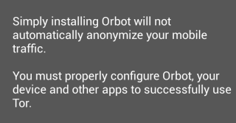

**Step 5:** A screen will appear asking you to grant **Orbot**Superuser access. Superuser access requires that your device is rooted if you want to make use of **Orbot's**Transparent Proxy features - we will not explore this feature in the **Orbot**guide. (For information about rooting your phone, see the **Mobile Phones, Expert lesson**.)

If your smartphone is not rooted, just **tick**the option that states I understand and would like to continue without Superuser. The next screen explains in order for you to benefit from Tor, you will need to use apps built to work with **Orbot**, or that support HTTP or SOCKS proxy.

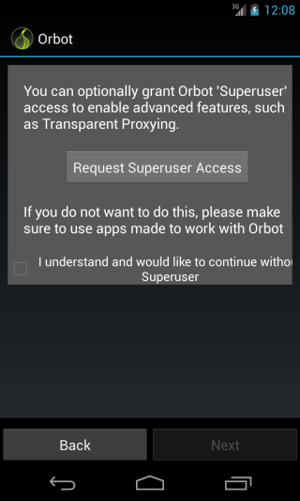

**Step 6:** A list of applications that work with **Orbot**will appear. Take note of them and **tap “**Next**”.**

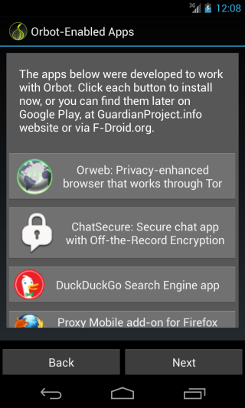

**Step 7:** **Orbot**configuration is now complete. A final screen describing the typical users of **Tor**and **Orbot**will appear, once you have read this **tap**“Finish”.

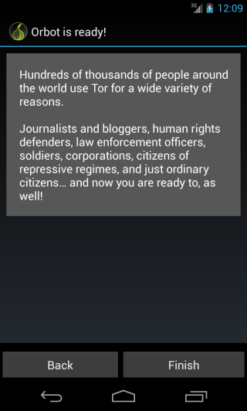

**Step 8:** After pressing “Finish” you will be presented with the deactivated **Orbot**screen.

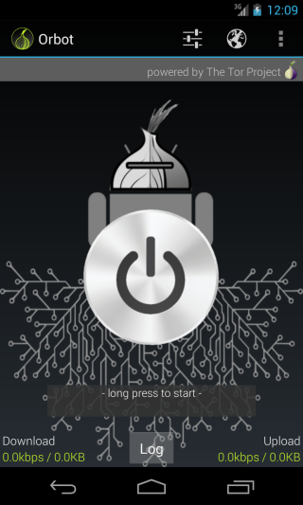

### 3. How to Use Orbot

3.0 Basic Usage

3.0.1 Starting and Stopping Orbot

3.0.2 Browsing the internet anonymously

3.1 Advanced Usage

3.1.1 New Identity

3.1.2 Using Bridges

3.1.3 Auto Starting Orbot

## 3.0 Basic Usage

## 3.0.1 Starting and Stopping Orbot

**Step 1:** **Touch and hold**the grey **Orbot**icon in the centre of the screen until it turns yellow and says Orbot is starting.

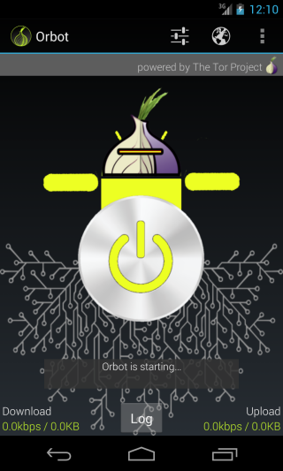

**Step 2:** The first time you start **Orbot**a notification will appear to confirm you connected successfully to the **Tor**network. You will only see the notification screen the first time you start **Orbot**after installation. **Tap**“OK” to see the green **Orbot**indication that **Orbot**is running.

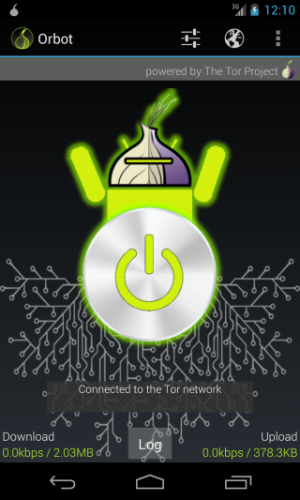

**Step 3:** To disconnect **Orbot**you **touch and hold**the green **Orbot**until it turns grey. Or if you want to disconnect and quit **Orbot, tap**the menu icon (three vertical dots in the top right of the screen) in the top right of the screen and select “Exit”.

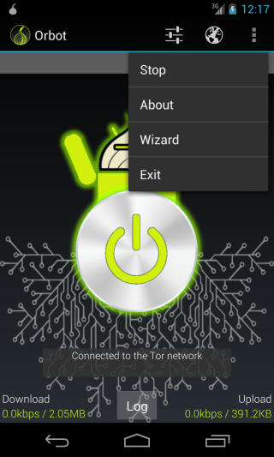

## 3.0.2 Browsing the internet anonymously

In order to browse or chat on the internet anonymously, you need to install an app which can route your browsing through a proxy in conjunction with **Orbot**. This is what Orbweb, the tool outlined below will do for you.

## 3.1 Advanced Usage

## 3.1.1 New Identity

If at any stage you want to appear to come from a new location, you can get a new identity from **Orbot**by **swiping**left or right on the green **Orbot**image. The image will briefly spin and then display You've switched to a new Tor Identity.

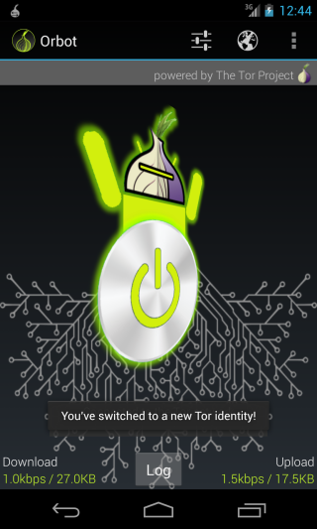

## 3.1.2 Using Bridges

If **Tor**access is restricted or illegal in your country, or you wish to disguise the fact that you are using **Tor**, you can configure **Orbot**to use **bridges**.

**Step 1:** **Tap**the icon with three staggered dots at the top of the screen to be brought to the settings screen.

**Step 2:** Scroll down to the **bridges**section and check the box next to Use Bridges.

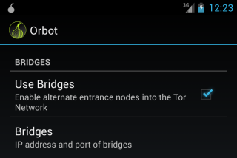

**Step 3:** **Tap** the Bridges section underneath Use Bridges to be presented with a screen to enter the IP address of the bridge you want to use. Once correctly entered, **tap**“OK”. Restart **Orbot**to begin using the bridge.

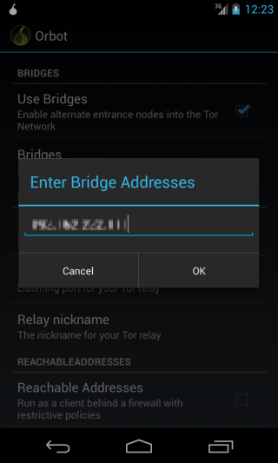

## 3.1.3 Auto Starting Orbot

To make sure you never forget to start **Orbot**it can be configured to start when you turn on your Android Device.

**Step 1:** **Tap**the icon with three staggered dots at the top of the screen to be brought to the settings screen.

**Step 2:** **Check**the Start Orbot on boot option at the top of the settings screen.

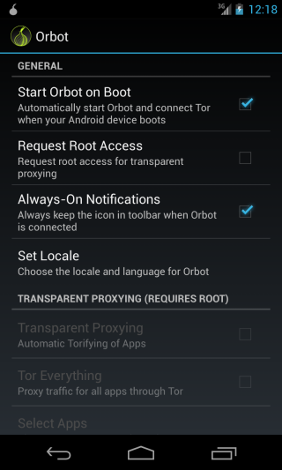

# ORWEB

# 

## 1.1 Things you should know about this tool before you start

Orweb is a free Android-platform mobile phone application, created by the Guardian Project for browsing the internet anonymously in conjunction with Orbot.

**Note:** There is a bug in the current version of **Orweb**(0.6.1 and older) that may leak information about you, such as your IP address, to the website owners if you are viewing HTML5 based videos. **Orweb**will still allow you to circumvent censorship and prevent you from being spied on by your Internet Service Provider(ISP) but we do not recommend itto be used to view sites that may be considered hostile. For more information on the issue see the developers' response.

**Orweb**will only work properly after installing and configuring Orbot.

Remember, if you previously created a mail or blog without using **Orweb**, the site will still know your real location even if you return using **Orweb**.

If you want stronger anonymity while using **Orweb**other steps need to be taken including:

* Never access accounts made in your real name
* Never give your personal data
* Never do the same things that you do when not trying to be anonymous.

For an alternative that works with iOS on iPhones, use [**OnionBrowser**](https://mike.tig.as/onionbrowser/)**.**

### 2.0 How to Install Orweb

**Step 1:** On your Android device, **download**and **install**the app from the [**Google Play store here**](https://play.google.com/store/apps/details?id=info.guardianproject.browser) by tapping “Install”.

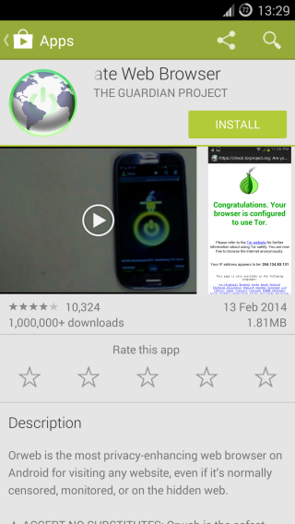

**Step 2:** Before the installation process begins, you will be prompted to review the access the application will have on your phone. Review this carefully. Once you are happy with the permissions that will be granted, press “Accept” to start the installation. If you do not agree with the permissions that will be granted, press the back button and the installation will be cancelled.

**Step 3:** Once **Orweb**downloads and installation has completed, you can press “Open” to start the application.

### 3. How to Use Orweb

## 3.0 Basic Usage

## 3.1 Advanced Usage

## 3.1.1 Change User Agent

## 3.1.2 Clear Browsing History

## 3.1.2.1 Manually

## 3.1.2.2 Automatically

## 3.1.3 Clear Cookies

## 3.0 Basic Usage

### Using Orweb for the first time

**Step 1:** To open Orweb you **tap**the application's icon.



**Step 2:** **Orweb**will launch and automatically try to connect to https://check.torproject.org, to ensure that its connection to the **Tor**network is working. If it can connect, you will see a message telling you that your browser is configured to use Tor. If **Orweb**cannot connect to the website you will see an error message in the browser. If this happens, it is suggested that you check that Orbot is installed and running corectly on your android device if this happens.

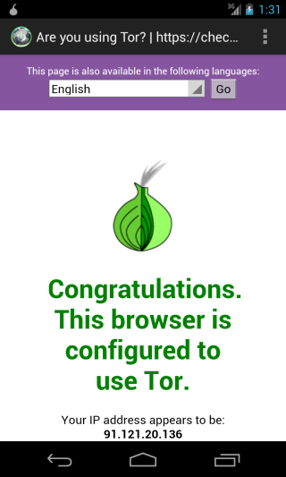

**Step 3:** To browse to websites, **tap**the area at the top of the screen to the right of the Orweb icon and type in the address you want to visit. Press “**Go”**on the onscreen keypad.

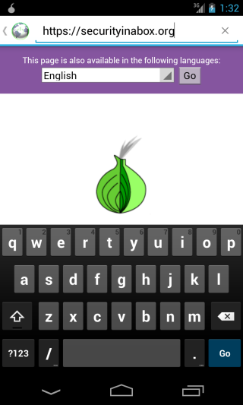

## 3.1 Advanced Usage

## 3.1.1 Change User Agent

If you want to hide the type of device that you are using from the websites you visit, **Orweb**can be configured to pretend to be a number of different devices.

**Step 1:** **Tap**on the menu icon (three vertical dots) found in the top right of the screen and **tap “**Settings**”**.

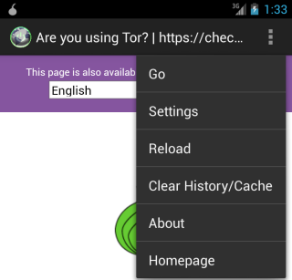

**Step 2:** Once in the settings section, scroll down to the **Privacy**section and **tap**“User Agent”.

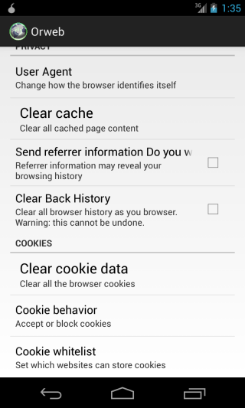

**Step 3:** You will be presented with a list of User Agents. **Tap**your choice (e.g. Tap iPhone to set it. Now any time you visit a website, it will think you are using an iPhone).

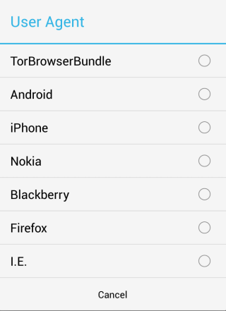

## 3.1.2 Clear Browsing History

## 3.1.2.1 Manually

To manually clear your browsing history and cache, and to hide the websites you have been visiting on your phone, **tap**on the menu icon (three vertical dots) and press “Clear History/Cache”.

## 3.1.2.2 Automatically

To automatically remove your browsing history and cache as you go to a new page:

**Step 1:** **Tap**on the menu icon (three vertical dots) followed by “Settings”.

**Step 2:** In the **settings**screen, scroll down and **tap**Clear Back History.

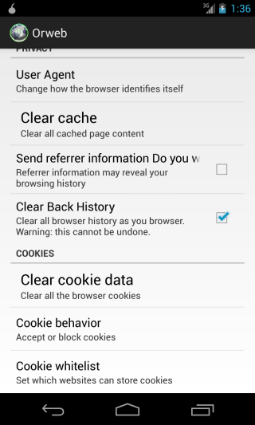

Note: When you set this, you will not be able to press the back button to view web pages you have already visited.

## 3.1.3 Clearing Cookies

**Note:** Deleting cookies will sign you out of any websites that you were logged into.

**Step 1:** **Tap**on the menu icon (three vertical dots) found in the top right of the screen and **tap “Settings”.**

**Step 2:** Scroll down to the **Cookies**section and press “Clear cookie data”.

**Step 3:** **Tap**“OK” to confirm the deleting of cookies.

